Communication Diagram details-
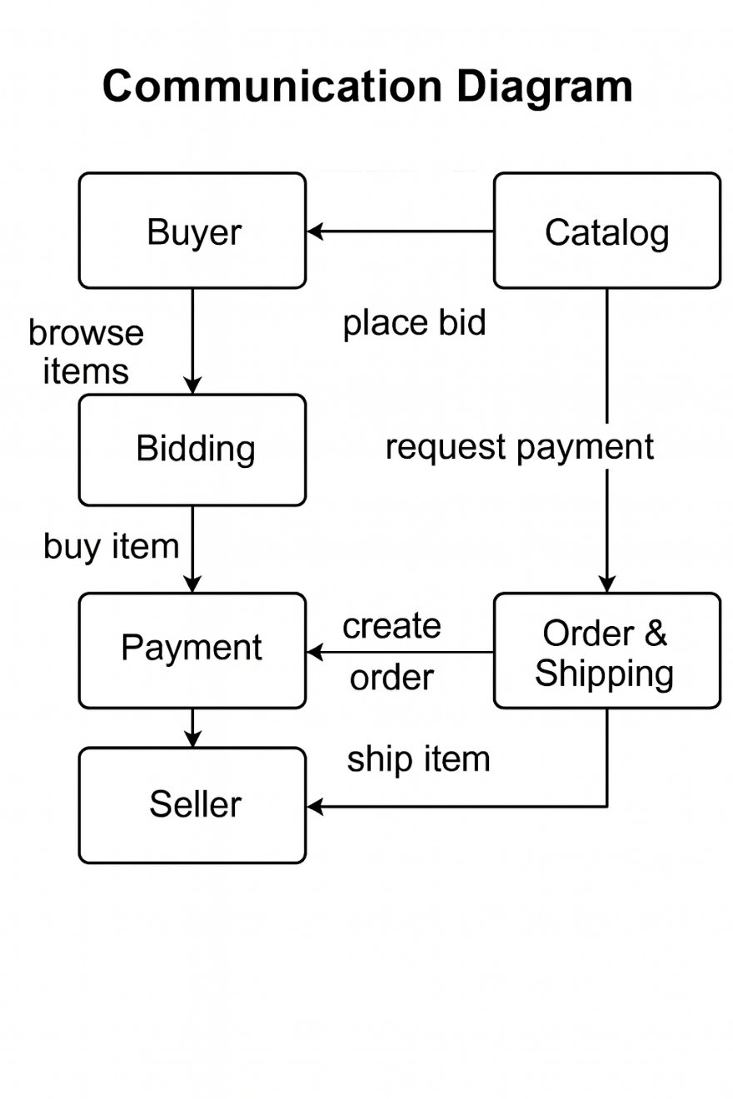

Entities and Their Roles:
Entity | Role in the System
Buyer | Initiates the transaction by browsing items and placing bids
Catalog | Displays available items and handles bid placement and payment requests
Bidding | Manages the bidding process, allowing buyers to compete for items
Payment | Processes financial transactions once a bid is accepted
Order & Shipping | Creates orders and manages logistics for item delivery
Seller | Fulfils the order by shipping the item

Interaction Flow Explained
- Buyer → Catalog: "Place Bid"
  - The buyer selects an item and places a bid via the catalog interface.
  - This triggers the catalog to initiate the bidding process.
- Buyer → Bidding: "Buy Item"
  - If the bid is successful or the item is available for direct purchase, the buyer proceeds to finalize the purchase through the bidding system.
- Catalog → Payment: "Request Payment"
  - Once the buyer commits to the purchase, the catalog requests payment authorization.
- Bidding → Payment: "Buy Item"
  - The bidding system confirms the buyer’s intent and passes control to the payment system for transaction processing.
- Payment → Order & Shipping: "Create Order"
  - After successful payment, the system generates an order and initiates shipping logistics.
- Order & Shipping → Seller: "Ship Item"
  - The seller receives the order details and ships the item to the buyer.

